ENDOCRINE EMERGENCY GUIDELINES (Updated 1.8.13 RL)

Hypoglycemia
- If low BS and cause unknown, GET CRITICAL SAMPLE PRIOR TO TREATMENT!
- *Labs tested during hypoglycemia are critical to identifying cause and preventing recurrence*
  - Serum critical sample
    - BMP Insulin, C-peptide, Cortisol, GH
    - Free fatty acids, B-hydoxybutyrate, Acetoacetate
    - Lactate, Ammonia, Save serum (sulfonylureas), Total and Free carnitine
  - At any time
    - Acylcarnitine profile, serum amino acids,
  - Urine – as quickly after hypoglycemia as possible
    - Urine ketones
    - Urine Organic acids
  - If suspect hyperinsulinism, glucagon stim test (0.03mg/kg, max 1 mg) and measure lab glucose at 0, 15, and 30 minutes
- Acute Treatment: obtain critical sample and correct hypoglycemia within 10-15 minutes
  - IV or IO dextrose bolus (D10%, or D25%), followed by continuous infusion of Dextrose IVF and frequent blood sugar checks (q1-2 hrs initially, maybe more frequent)
    - D25% 2-4 ml/kg; D10 5-10 ml/kg (neonates 2 ml/kg D10)
  - IF insulin-mediated, treat with glucagon 0.03 mg/kg up to 1 mg OR 0.5 mg IM <20kg, 1 mg IM >20 kg

Adrenal Insufficiency
- Critical Sample before treatment: cortisol
  - If suspect primary adrenal insufficiency, include ACTH, renin, aldosterone
  - If suspect CAH, include 17OH-progesterone or CAH-6b panel
  - Also check BMP, CBC, U/A
- Treat while awaiting results
  - Normal Saline Bolus 20ml/kg
  - Hydrocortisone 50-100 mg/m2 IV bolus (lower end of range if less sick, higher end of range if more sick) followed by 50-65 mg/m2/day, divided q6h
    - If no IV access, SoluCortef IM or Dexamethasone IM
    - SoluCortef 50-65 mg/m² IV/IM – short acting
      - At this dose, adequate mineralocorticoid activity to replace moderate doses of oral fludrocortisone (80 mg HC = 0.2 mg fludrocortisone)
    - Dexamethasone 1.5-2 mg/m² IV/IM—long acting
      - No mineralocorticoid activity
      - Does not cross react with cortisol in lab assay so can use Dex if unable to get cortisol before treatment and then do Cortrosyn stimulation test after treatment
    - SoluMedrol 10-15 mg/m² IV/IM–intermediate acting
      - No mineralocorticoid activity
  - For milder presentation, ex. known diagnosis with flu symptoms, but hemodynamically stable, can skip load, use 50-65/m²/day, divided every 6 hours.
- Known adrenal insufficiency (ie CAH or hypopituitarism) and adrenal crisis
  - Loading dose hydrocortisone IV or IM 50mg/m2 x1 then 50mg/m2/day divided q6hrs
  - If BSA unknown or for more rapid dosing, can use age:
    - <3 y.o.: 25mg bolus followed by 25-30mg/day divided q6hrs
    - 3-12 y.o.: 50mg bolus followed by 50-60mg/day divided q6hrs
    - >12 y.o.: 100mg bolus followed by 100mg/day divided q6hrs
  - If severely ill or unable to take PO due to continued emesis, but no IV, can give SoluCortef 30-50mg/m2 IM (better for CAH because has fludrocortisone activity at high doses, but only lasts about 6 hours), or Dexamethasone 1.5-2mg/m2 IM (better for panhypopit because they don’t need mineralocorticoid replacement and lasts 24hrs)
  - If less ill (ie, not in crisis but needs stress doses because of fever or vomiting), can give double or triple oral dose (usually double if fever, triple if vomiting or more sick)
  - Normal saline bolus 20ml/kg/ IV then D5NS or D10NS (depending on blood sugar) at 1.5 x maintenance
  - Monitor electrolytes, BP
  - For anesthesia: begin triple dose the night before the procedure, then 30-50mg/m2 IV or IM on call to the OR prior to anesthesia; and continue stress doing for 24 hrs after procedure

Hypercalcemia
- Critical sample: Ca, Phos, iPTH
  - Other labs: 25OHD, 1,25OH₂D, urine ca/cr, CBC
- Treatment for severe hypercalcemia (Ca >14): same initial treatment independent of the cause
  - Saline diuresis: NS bolus followed by 2.5-3L/m²/da
    - Saline diuresis generally works rapidly, but only as long at it is continued, and usually does not normalize calcium.
  - Begin Lasix 1 mg/kg/dose every 4-6 hours only when adequate hydration is achieved
    - Decreases bone resorption and increases urinary excretion of Ca and Phos
  - Calcitonin 4 units/kg IV/IM/SC q 12 hrs
    - Tachyphylaxis common (often 2nd-line therapy y
    - Common side effects: nausea, vomiting, flushing
  - Discontinue any medications known to cause or worsen hypercalcemia
  - Avoid immobilization
- If mild/moderate (Ca <13-14) and no contraindication to PO: 2-3 L/day water plus PO salt to promote Ca excretion
- Therapy specific for underlying disorder
  - Hyperparathyroidism parathyroidectomy
  - Glucocorticoids effective if associated with hematologic malignancy or diseases with increased 1,25 (OH)₂ vitamin D.

Hypocalcemia
- Critical sample: Calcium, Phosphorus, Magnesium, intact PTH before treatment
  - Ca and PTH need to be simultaneous, and PTH MUST be obtained while Ca is low
  - Collect urine Ca/Cr while Ca low if possible
  - If there is reason to suspect low albumin, check ionized calcium or calculate corrected calcium using albumin
    - Corr Ca = measured calcium + [0.8 (4-albumin)]
  - Other useful labs: CMP (kidney, liver, bone function), 25OHD, 1,25OH₂D, urine Ca/Cr
- Treatment if Symptomatic - tetany, sz, apnea, heart failure, laryngospasm
  - Slow (<1 ml/min) IV infusion 10% Ca gluconate 1 ml/kg
    - 100 mg/ml Ca Gluconate = 9 mg/ml elemental Ca
    - Cardiac monitoring (bradycardia, shortened QTc); close attention to infusion site if not central IV (risk of tissue necrosis if peripheral IV infiltration)
  - If Mg low, replace with 0.1-0.2 ml/kg 50% Mg Sulfate
- If not acutely symptomatic, can do more comprehensive eval first to determine cause and appropriate oral treatment

Thyroid Storm (Thyrotoxic Crisis)
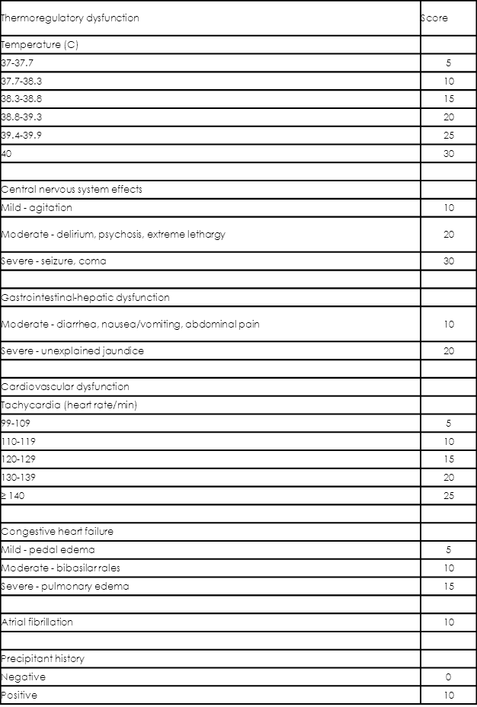
≥45, highly suggestive of thyroid storm; 25–44, thyroid storm; and <25, thyroid storm unlikely.

- Critical Sample: Free T4 and TSH run STAT
  - Other labs: TBII, TSI, TPO antibodies
  - Useful to measure: CMP (glucose, liver function), CBC (acute infection?), urine pregnancy test
- Acute Treatment
  - Oxygen
  - Adrenergic blockade (if not in CHF) - goal HR<100
    - Propranolol (PO 2mg/kg/day div Q6-8 hrs or IV 0.01mg/kg/dose (max 5mg) over 10-15 min)
    - If contraindication to propranolol (ie asthma), can use atenolol (cardioselective) with caution
  - IV fluids (cooled if necessary)
  - Cooling blankets
  - Antipyretics should be avoided when possible
  - Sedation – phenobarbital stimulated thyroid hormone clearance
  - Hemodynamic support/treat CHF if present
- Longer term treatment:
  - Block thyroid hormone synthesis and release
    - Thionamides – block thyroid hormone synthesis
      - PTU (propylthiouracil): black box warning in peds
      - Methimazole : ~0.8 mg/kg up to 60 mg loading, then ~0.4 mg/kg up to 30 mg every 6 hours (5, 10 mg tabs)
    - High Dose Iodine – blocks release of already formed thyroid hormone
      - Should be delayed until 1-2 hours after thionamide, to prevent transient increase in thyroid hormone levels
      - SSKI (Lugol solution) 5 drops every 6-12 hours
      - Use will necessitate delay in radioactive iodine treatment if that is desired
  - Block peripheral conversion of T4 to T3
    - Corticosteroids (stress dose HC or equivalent)
    - Propranolol
    - Iodinated contrast agents
- Identify and treat precipitating event causing severe decompensation
  - infection, pregnancy, emotional stress, DKA, pulmonary embolism, CVA, trauma, hypoglycemia
- Assess for underlying cause
  - Grave’s disease, functioning thyroid nodule (“hot nodule”)

